**PUBLICATION FORMAT**

**Length of the publication:**  
3000 – 5000 words, including the abstract and bibliography. These values cover all parts of the paper, so please adhere to this length.  
If the paper exceeds the specified length, it will be returned for revision before being evaluated by reviewers.

**Title and Author(s) Information:**

* At the top of the first page, provide the full title of the paper (font size 12). The title should be concise but accurately reflect the subject of the paper.
* After the title, on a separate line, provide the full names of the authors (font size 10), their affiliations (department, university, address), and the contact details of the corresponding author (email address) – font size 8.

**Example:**  
*Longitudinal Effects of Employees’ Big Five Personality Traits on Internal Promotions Differentiated by Job Level in a Multinational Company*  
Tobias L. Kordsmeyer ¹, Andrew B. Speer ², Rafael Wilms ³, Rainer Kurz ⁴  
✉ Tobias L. Kordsmeyer, tob.kor@gmail.com

1. Department of Psychology & Leibniz ScienceCampus Primate Cognition, University of Goettingen, Gosslerstr. 14, 37073 Goettingen, Germany
2. Department of Psychology, Wayne State University, 5057 Woodward Avenue, Detroit, MI 48202, USA
3. Department of Management and Organisation, Vrije Universiteit Amsterdam, De Boelelaan 1105, 1081 HV Amsterdam, Netherlands
4. HUCAMA Analytics Ltd., 112C High Street, Hadleigh, Ipswich IP7 5EL, UK

**Abstract:**  
The abstract should be between **200 and 300 words** and may be written in Polish or English.  
The abstract should include the following information:

* **Background** – Introduction and research problem
* **Aim** – Research objective
* **Method** – Research methodology: experimental model, correlation, case study; statistical methods, sample characteristics
* **Results** – Research findings
* **Conclusions** – Summary, discussion, conclusion
* **Keywords** – List of key terms

**Keywords:**  
After the abstract, provide **3 to 5 keywords** (font size 10) that best describe the subject of the paper.

* Keywords should be precise and selected to ensure easy retrieval of the publication in databases.
* Keywords should be written in the language of the conference (e.g., Polish/English) and separated by commas.

**Examples:**  
**Keywords:** developmental psychology, experimental research, motivation, emotions  
**Keywords:** Big Five, Personality factors, Personality facets, Promotion, Job level

**Document Format:**

* The document should be prepared in **Microsoft Word (.doc/.docx)** or **PDF** format.
* Please avoid using other formats to facilitate document review and processing.

**Text Layout:**

* **Font:** Times New Roman, size 12
* **Line spacing:** 1.5
* **Margins:** 2.5 cm on each side
* **Page numbering:** Please number pages in the bottom right corner
* **Headings and section division:**
  + Use headings and subheadings for better text structuring
  + **Main headings:** bold, size 14
  + **Subheadings:** bold, size 12
* **Text alignment:** Left-aligned, except for the title and abstract, which should be centered

**Citations and Bibliography:**

* **Citation style:** Please use the latest version of the APA style (APA 7th edition) for citing sources in the text and in the bibliography.
* **In-text citations** should be provided in the following format:
  + (Author, year) or (Author, year, page) for direct quotes
* **Bibliography** at the end of the paper should include complete details of all cited sources, following APA 7th edition guidelines.

**Examples:**  
a) **Journal Articles**  
Kordsmeyer, T. L., Speer, A. B., Wilms, R., & Kurz, R. (2024). Longitudinal Effects of Employees’ Big Five Personality Traits on Internal Promotions Differentiated by Job Level in a Multinational Company. *Journal of Business & Psychology*, 39(5), 1049–1065. <https://doi.org/10.1007/s10869-023-09930-7>

Logan, T. K. (2024). Associations of stalking victims’ reports on ex-partners’ far-right extremist beliefs and threats of intimate and nonintimate violence. *Journal of Threat Assessment and Management*. <https://doi.org/10.1037/tam0000243>

b) **Book**  
Brzeziński, J. M. (2019). *Metodologia badań psychologicznych*. New edition. PWN.  
Zimbardo, P. (2007). *The Lucifer Effect: Understanding How Good People Turn Evil*. Random House, Rider.

c) **Edited Book**  
Cierpiałkowska, L., & Sęk, H. (Eds.). (2020). *Psychologia kliniczna*. PWN.  
Szymkiewicz, B. (Ed.). (2013). *Psychologia procesu. Teoria i praktyka*. Eneteia.  
Fosha, D., Siegel, D. J., & Solomon, M. F. (Eds.). (2009). *The Healing Power Of Emotion. Affective Neuroscience, Development & Clinical Practice*. W. W. Norton & Company.

d) **Chapter in Edited Volume**  
Kałowski, P. (2020). Narration True and False: Dialogical Self Theory in Psychotherapy. In B. Bokus & E. Kosowska (Eds.), *Truth and Falsehood in Science and the Arts* (pp. 189-204). University of Warsaw.

**Tables and Figures:**

* Figures, tables, and charts should be properly labeled, numbered, and referenced in the text.
* All graphic materials must be included in the same file as the text and should have sufficient quality for clear readability (recommended minimum is **300 DPI** for images).

**Examples:**

* **Tables:** Include the table number (in Arabic numerals) and a title in italics above the table. Provide the source of the data below the table in italics, following the format:

*Table 1* – Example of table formatting

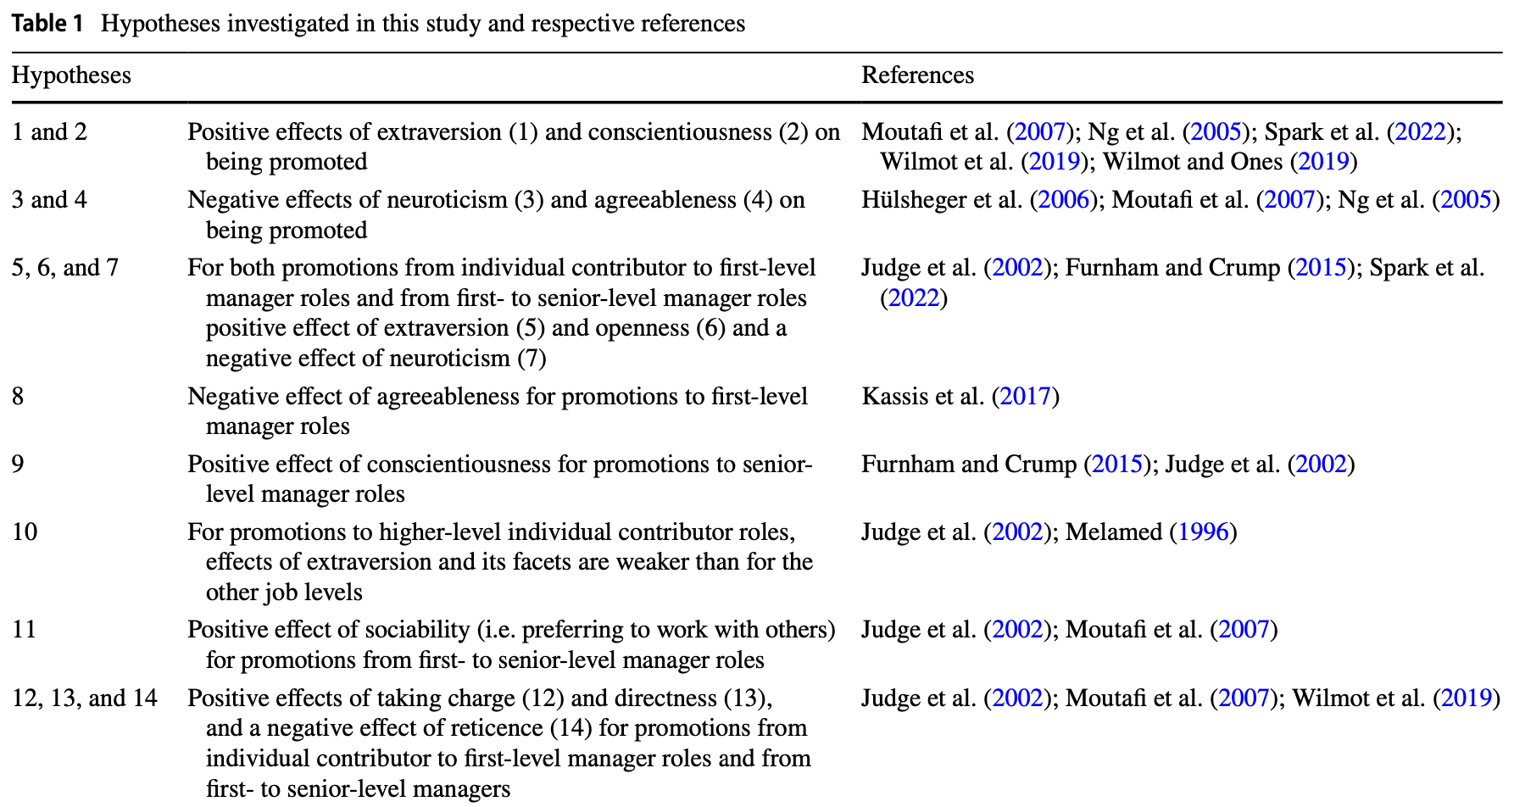

*Source:* Kordsmeyer, T. L., Speer, A. B., Wilms, R., & Kurz, R. (2024). Longitudinal Effects of Employees’ Big Five Personality Traits on Internal Promotions Differentiated by Job Level in a Multinational Company. *Journal of Business & Psychology*, 39(5), 1049–1065. <https://doi.org/10.1007/s10869-023-09930-7>

* **Figures (drawings, charts, diagrams, photos, maps):** Use font size 10 pt. Include the number (in Arabic numerals), title, and source information below the figure. The terms "Figure" and "Source" should be in italics.

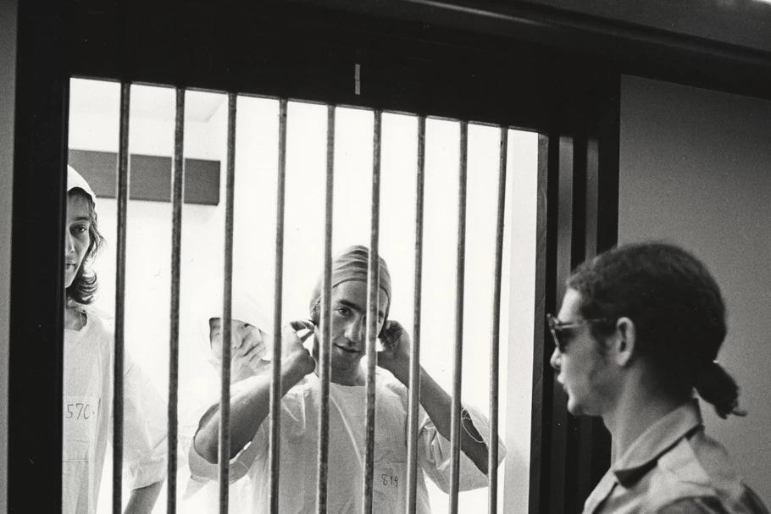

*Figure 1.* Stanford Prison Experiment  
*Source:* <https://www.newsweek.pl/>

**Footnotes:**  
APA style distinguishes between two types of footnotes:

1. Footnotes supplementing key information in the main text (more common).
2. Footnotes providing copyright information for a work protected by copyright (more common practice is to provide copyright information directly below the table, figure, or other element).